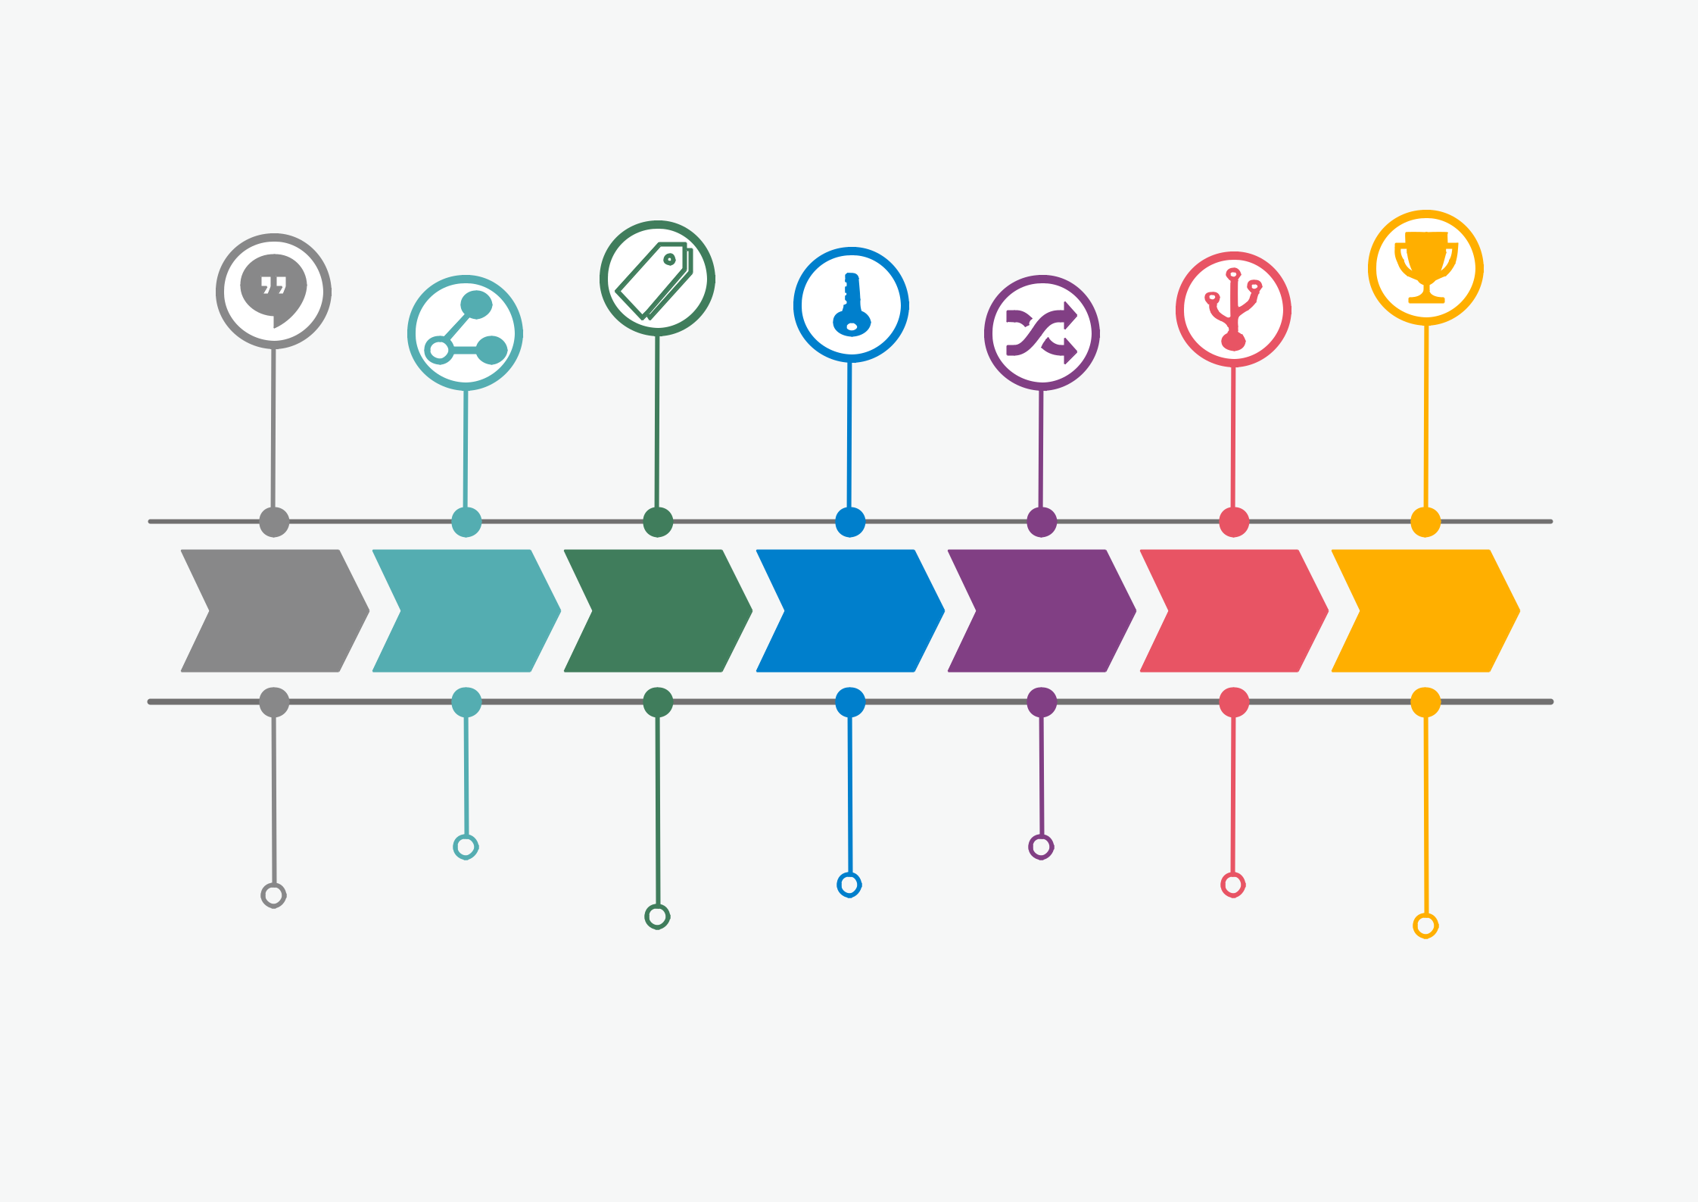
ACTION PLAN : [Rajae DOUIMI]

2021 2022 2023 2024 2025 2026 2027

 | Move out to my new home
Learn english
Learn english | Get done with the constructions and buy new furnitures
 |  | Travel around
Finish the ESTEEM program
 |  | Buy a new car and visit the southern region of morocco
 |  | text here!

