**Samia abed al Rahim Abu Shanab**

**questions**

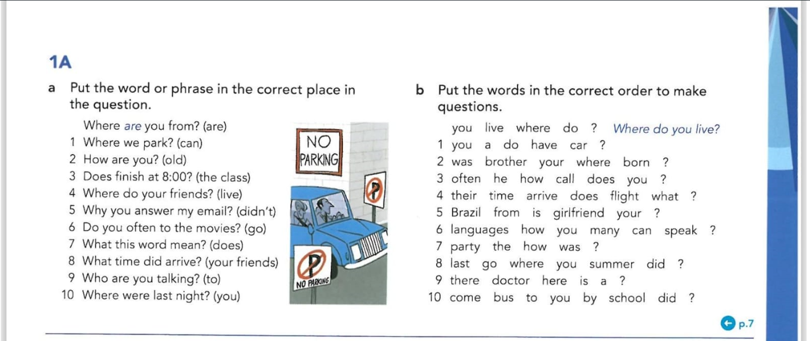

**Answres**

|  |  |
| --- | --- |
| 1A . a   1. Where we can park? 2. How old are you? 3. Dose the class finish at 8:00? 4. Where do your friends live? 5. Why you didn’t answer my email? 6. Do you often go to the movies? 7. What does this word mean? 8. What time did your friends arrive? 9. Who are you talking to? 10. Where were you last night? | 1A . b   1. Do you have a car? 2. Where was your brother born? 3. How often does he call you? 4. What time dose their flight arrives? 5. Is your girlfriend from Brazil? 6. How can you speak many languages? 7. How was the party? 8. Where did you go last summer? 9. Is there a doctor here? 10. Did you come to school by bus? |