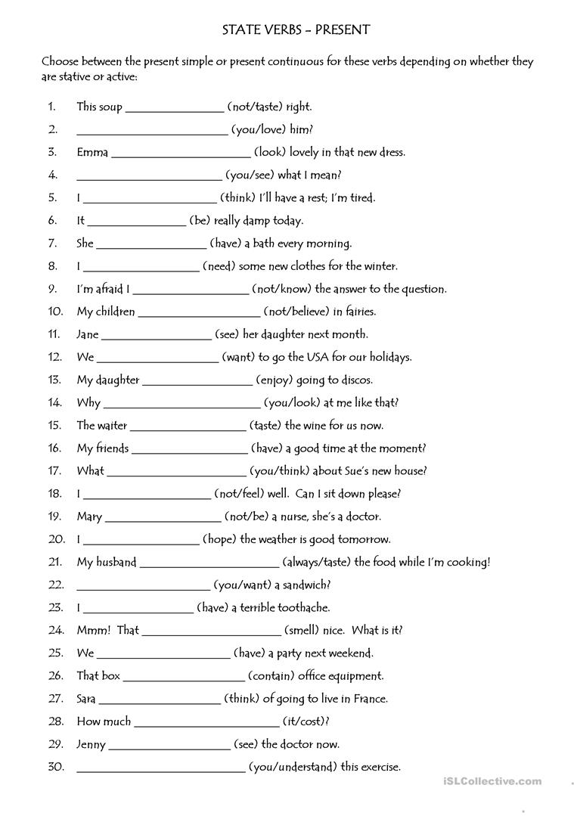

You understand

is seeing

it costs

Is thinking

Contains

have

is smelling nice

am having

you want

always taste

hope

isn’t

am not feeling

You think

Are having

is tasting

Are looking

Is enjoing

want

see

Dosen’t believe

Don’t know

need

Is having

is

I think

You see

Is looking

You love

Dosen’t taste