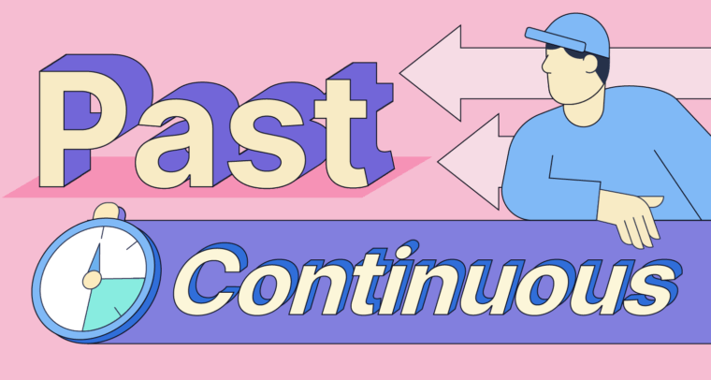

Past continuous

The past continuous shows us that the action in progress at a certain time in the past.

*What were you doing at 8 p.m. last night?*

*I was studying. I was sleeping.*

This means that I started studying before 8 p.m. and I continued after 8 p.m.

We make the past continuous with *was* or *were* and the -*ing* form of the verb.

I, He, she, it = was

You, we, they =were

*We also use the simple past and past continuous in the same sentence to talk about an interrupted action. .

We **were playing** football ( long action) when it **started** to rain. (short action)

Past continuous simple past

I was reading a book ( long action) when the phone **rang.** . (short action)

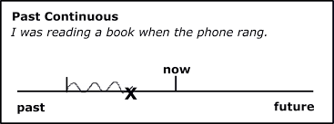Past continuous simple past