cough | Picture 9
a headache | Picture 6
a rash | Picture 1
a temperature | Picture 4
sunburn | Picture 2
She’s sick. / She’s vomiting. | Picture 8
She’s sneezing. | Picture 10
Her ankle’s swollen. | Picture 3
Her back hurts. / Her back aches. | Picture 7
Her finger’s bleeding. | Picture 5
Samia Abu shanab
1 - Page 152 Vocabulary Bank (Illnesses and Injuries) - All exercises
- Match the words to the pictures.

c. Match the illnesses and conditions with their cause or symptoms.
Here are the correct matches:
- He has a sore throat. - B It hurts when he talks or swallows food.
- He has diarrhea. - D He’s been to the bathroom five times this morning.
- He feels sick. - E He feels like he’s going to vomit.
- He’s fainted. - C It’s so hot in the room that he’s lost consciousness.
- He has a blister on his foot. - H He’s been walking in uncomfortable shoes.
- He has a cold. - F He’s sneezing a lot and he has a cough.
- He has the flu. - A He has a temperature and he aches all over.
- He feels dizzy. - G He feels like everything is spinning around.
- He’s cut himself. - I He’s bleeding.

2. Injuries and More Serious Conditions - Answers

2a. Match the injuries with their causes or symptoms.
- He’s unconscious. - C He’s breathing, but his eyes are closed and he can’t hear or feel anything.
- He’s had an allergic reaction. - G He was stung by a wasp and now he has a rash and has difficulty breathing.
- He’s sprained his ankle. - B He fell badly and now it’s swollen.
- He has high (low) blood pressure. - D It’s 180 over 140.
- He has food poisoning. - E He ate some chicken that wasn’t fully cooked.
- He’s choking. - F He was eating a steak and a piece got stuck in his throat.
- He’s burned his hand. - A He spilled some boiling water on himself.

3. Phrasal Verbs Connected With Illness - Answers

3a. Match the bold phrasal verbs to their meanings.
- Pass out - faint
- lie down - put your body in a horizontal position
- throw up - vomit, be sick
- get over - get better / recover from something
- Come around - become conscious again

Clothes and Fashion – Answers

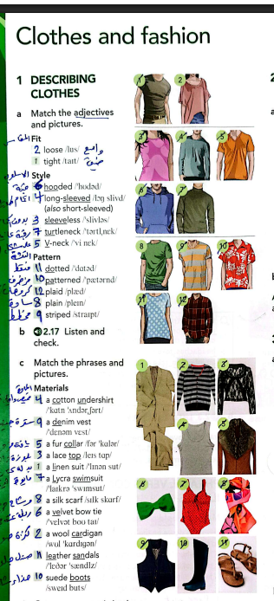

2a. Complete the sentences with an adjective.
(casual, classic, fashionable, old-fashioned, scruffy)
- She always wears casual clothes to work, she hates dressing formally.
- He looks really scruffy. His clothes are old and dirty.
- Jane looked very fashionable in her new suit. She wanted to make a good impression.
- That tie’s a little old-fashioned. Is it your dad’s?
- I like wearing classic clothes that don’t go out of fashion.

3a. Match the sentences.
- I’m going to dress up tonight. - C I’m going to a party.
- Please hang up your coat. - A Don’t leave it on the chair.
- These jeans don’t fit me. - F They’re too small.
- That skirt really suits you. - H You look great in it.
- Your bag matches your shoes. - G They’re almost the same color.
- I need to get changed. - B I just spilled coffee on my shirt.
- Hurry up and get undressed. - E It’s bath time.
- Get up and get dressed. - I Breakfast is on the table.
- That tie doesn’t really go with your shirt. - D They don’t look good together.

Now read each paragraph again carefully and choose a, b, or c.
b. worrying
(The text states: "The problem with Dr. Google is that the information is worrying.")
b. a lot of
(The text states: "Microsoft’s survey discovered that a lot of searches are about health.")
a. made her cyberchondria worse
(The text states: "The information the writer has found since coming back from the hospital has made her cyberchondria worse.")
a. don’t rank answers in order of probability
(The text states: "One of the problems with internet searches is that they don’t rank answers in order of probability.")
c. when and by who
(The text states: "Most people are unlikely to check when and by who health information was posted.")

Grammar Sections - Answers

Adjective Order
a. Rewrite the underlined phrase using the + an adjective.
- People from the Netherlands tend to be good at languages. - The Dutch
- Clara Barton took care of the people who weren’t well during the American Civil War. - The sick
- The system of reading for people who can’t see is called Braille. - The blind
- People from China have a fascinating history. - The Chinese
- Ambulances arrived to take the people who had been injured to the hospital. - The injured
- People from Switzerland are usually very punctual. - The Swiss
- The worst season for people without a home is winter. - The homeless
- There is a discount for people without a job. - The unemployed
- The World War II monument was erected to honor the people who died. - The dead
- There are special TV shows for people who can’t hear, that use sign language. - The deaf
b. Write the adjectives in parentheses in the correct place.
- a man (young / attractive) - an attractive young man
- shoes (old / dirty) - dirty old shoes
- a velvet jacket (black / beautiful) - a beautiful black velvet jacket
- a girl (teenage / tall / American) - a tall American teenage girl
- a beach (sandy / long) - a long sandy beach
- a log cabin (charming / old) - a charming old log cabin
- a leather bag (Italian / stylish) - a stylish Italian leather bag
- eyes (huge / dark) - huge dark eyes
- a dog (black / friendly / old) - a friendly old black dog
- a T-shirt (striped / cotton) - a striped cotton T-shirt

Present Perfect Simple & Continuous
a. Circle the correct form. Check (✔) if both are possible.
- She’s worked / been working here since July. ✔ (Both are possible)
- Your mother has called three times this morning!
- The kids are exhausted because they’ve been running around all day.
- Tim and Lucy haven’t seen our new house yet.
- I’ve never met her boyfriend. Have you?
- It’s been snowing all morning.
- My brother has lived / been living alone since his divorce. ✔ (Both are possible)
- I’ve been reading all morning. I’ve now read 100 pages.
b. Complete the sentence with the present perfect simple or continuous.
- We have known Jack and Ann for years. (know)
- You look really sweaty. Have you been working out at the gym? (you / work out)
- Emily has not done her homework yet, so I’m afraid she can’t go out. (not do)
- They don’t live in Toronto. They have moved. (move)
- I hope they’re getting along OK. They have been arguing a lot recently. (argue)
- We have been walking for an hour. Is this the right way? (walk)
- Why is my laptop on? Have you been using it? (you / use)
- Oh, no! I have cut my finger on this knife. (cut)

