How to Make a Groovy Worksheet

1. Find the film on you tube, pause at the point you want
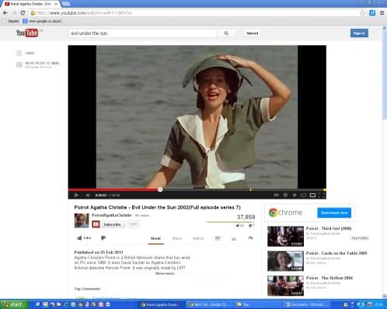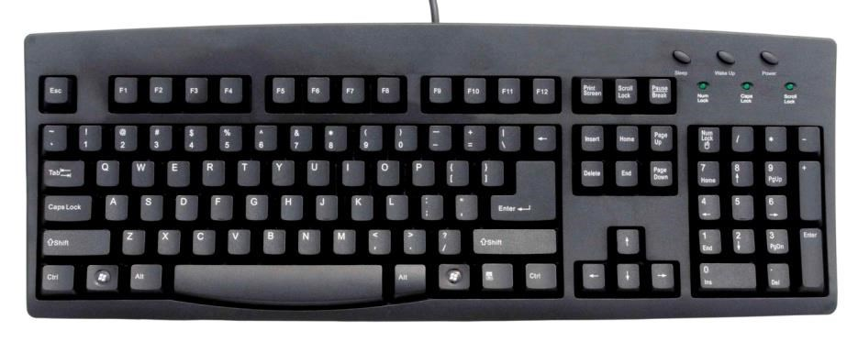

2
. P
ress ‘print screen’

3
.
On a blank page right
click and press
paste

4. Click on the picture
(ensure ‘picture’ tab is highlighted)

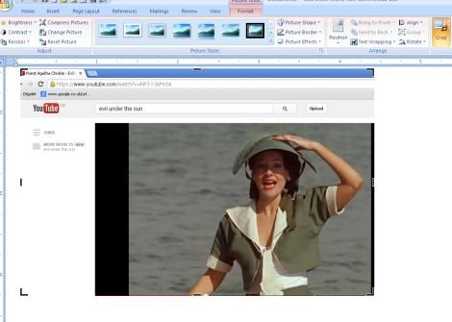

. C
5
rop the picture

. ‘ Free’ the picture by
6
clicking on
behind

or
in front

button in
text wrapping

7
. Choose a frame

8
. Rotate the picture

