**Intermediate 1 game: (related to giving opinions)**

In this group discussion activity, students practice giving opinions and asking embedded questions to gain more information. The students begin by naming ten controversial issues. These issues are written on the board, e.g. immigration, plastic surgery, cloning, animal testing, abortion, etc. The students are then divided into groups of four and each student is given a set of numbered opinion cards. The first student chooses a numbered card and a controversial issue from the board, e.g. card number 3 and cloning. Each student completes that numbered card with their opinion on the topic. The students then put their cards face down on the table and the four cards are mixed together. The first student picks up a card and reads out the opinion. The student then guesses who the card belongs to. After the writer of the card has been correctly identified or the first student reads out his or her own card, the group members use embedded questions to ask the writer to explain a little more about their opinion and feeling on the issue. If the students have opposing views, they have a brief debate on the issue. Afterwards, the second student chooses a numbered card and controversial issue and so on. When the students have finished, there is a class feedback session to find out which topics caused the most debate and who gave the most convincing arguments.

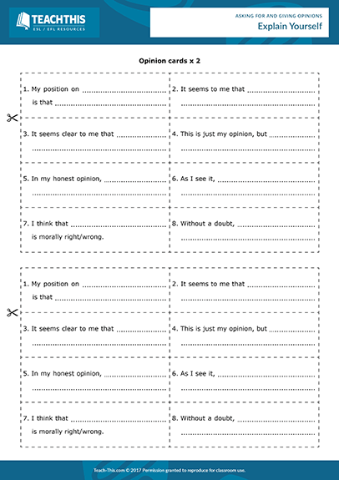

|  |  |
| --- | --- |
| 1. **My position on …………**   **Is that……………………** |  |
|  |  |
|  |  |
|  |  |
|  |  |