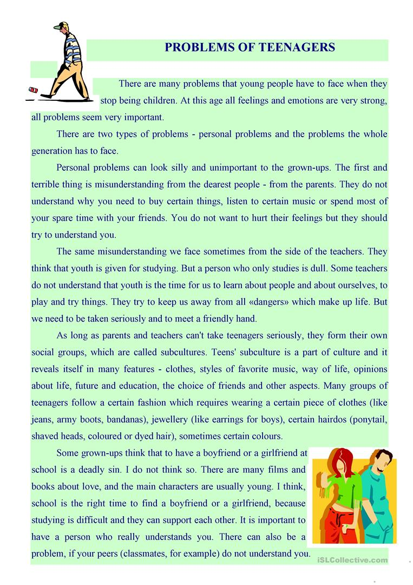

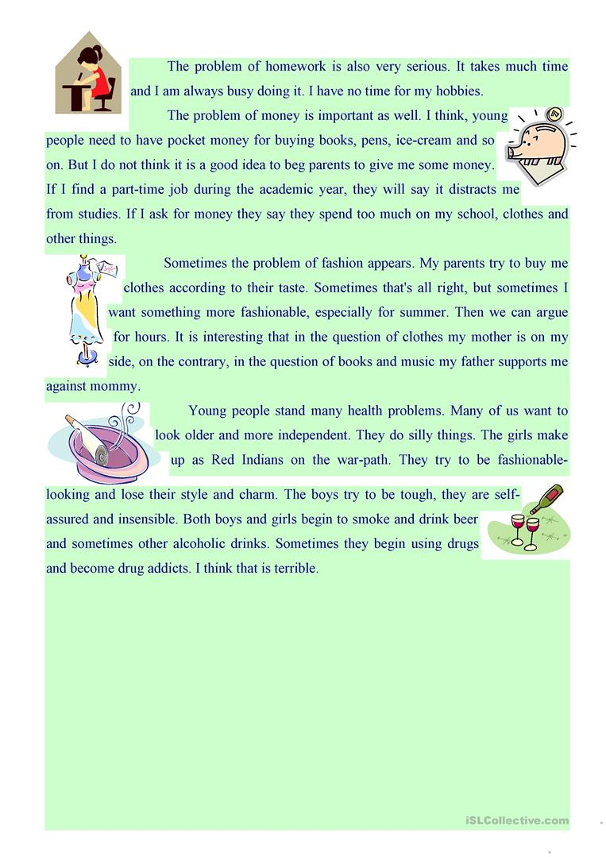

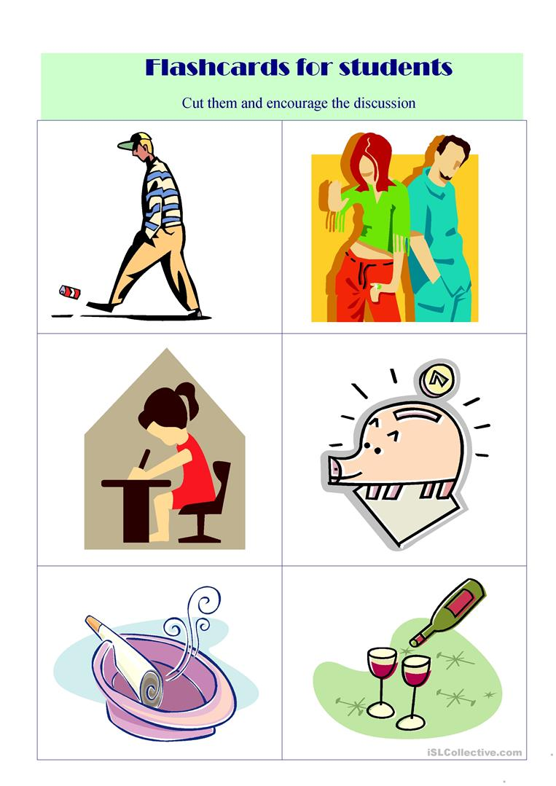

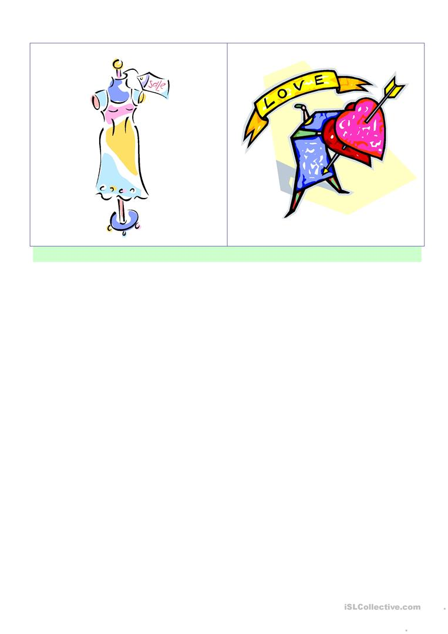

**Reading questions:**

According to the text, how many problems do teenagers have?

__________________________________________________________________________________________________________________________________________________________________________________________________________________________________________

In pairs, read the article again and try to find solutions for those problems.

Problem(1):_________________________________________________________________________________________________________________________________________________________________________________________________________________________________

Solution(1):_______________________________________________________________________________________________________________________________________________________________________________________________________________________________________________________________________________________________________________

Problem(2):_________________________________________________________________________________________________________________________________________________________________________________________________________________________________

Solution(2):_______________________________________________________________________________________________________________________________________________________________________________________________________________________________________________________________________________________________________________

Problem(3):_________________________________________________________________________________________________________________________________________________________________________________________________________________________________

______________________________________________________________________________

Solution(3):_______________________________________________________________________________________________________________________________________________________________________________________________________________________________________________________________________________________________________________

In groups, look at the flash cards and discuss the problems that are more likely to happen in those photos.

Swap the answers with the other groups and find solutions to those problems.