Learn vocabulary – jobs.

Do these exercises to help you learn different types of jobs.
1. Check your vocabulary: picture matching
Write the correct job in the box below the picture.
Photographer | Scientist | Receptionist | Farmer | Politician | Musician
Accountant | Actor | Interpreter | Librarian | Electrician | Lawyer

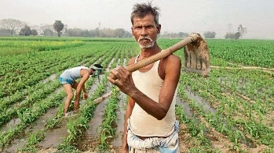 |  | 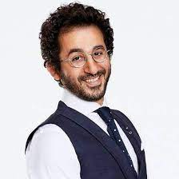 | 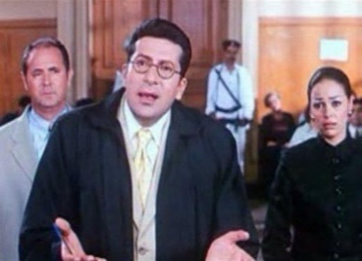
 |  |  | 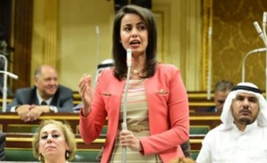
 |  |  | 

2. Check your vocabulary: gap fill
Write the name of a job to complete the sentences.
1. A _______________ is a person who works in a place such as a hotel, office, or hospital, who welcomes and helps visitors and answers the phone
2. An _______________ translates sign or spoken language.
3. A _______________ is a person who takes photographs, either as a job or hobby.
4. someone who works in a library, is trained in the organization or running of libraries, or is in charge of a library is called a _______________.
5. an expert who studies or works in one of the sciences is called a _______________.
6. a person who is active in politics, esp. as a job is called a _______________.
7. someone whose job is to give advice to people about the law and speak for them in court
is a _______________.
phone.
8. An _______________ Is someone who draws or paints paintings.
9. _______________ is a person someone who is skilled in playing music, usually as a job.
10. someone who pretends to be someone else while performing in a film, play, or television or radio programme is a _______________ .
11. an _______________is a person who puts in, checks, and repairs electrical wires and electrical equipment.
12. an _______________is someone who keeps or examines the records of money received, paid, and owed by a company or person.
Noha el sherbiny
Nohaelsherbiny22@hotmail.com

