https://www.youtube.com/watch?v=1MJrRvpjB1I

Step 1- Activity
Put your students into small groups and ask them to discuss how each pair of best friends are different.

Step 2-Dur
Tell your students they are going to watch the video again with no sound, but this time you are going to pause at each pair of best friends, and ask them to describe how they are different. Show the video and pause at each pair of best friends.

Step 3
Tell your students they are going to watch the video a third time without sound. This time they should speculate about what each child is saying about his/her best friend. Show the video pausing each time a child speaks and ask your students to speculate on what the child is saying. Encourage them to use “She may/might/could be saying …”

Step 4
Tell your students they are now going to watch the video with sound. As they watch and listen they should compare what they thought the children said with what they actually say.
Play with sound twice.

Step 5
Get feedback from your students on what they understood. Ask them if they are surprised by what the children said.

Step 6
Show these four screenshots from the video. Ask your students to comment on each photo and what the children say. You may need to explain that a “den” is a secret place where children you to play and that “tag” is a playground game that involves two or more players chasing other players in an attempt to “tag” or touch them, usually with their hands.

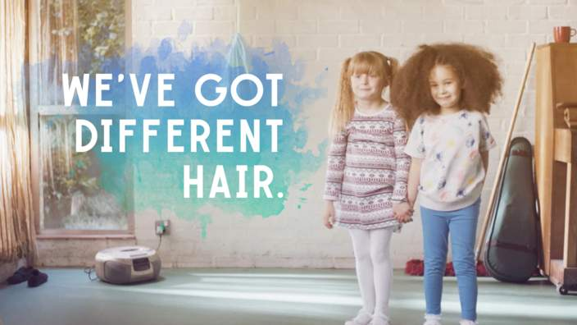
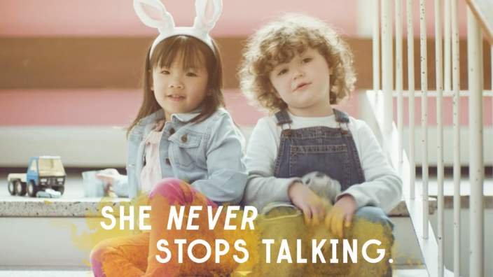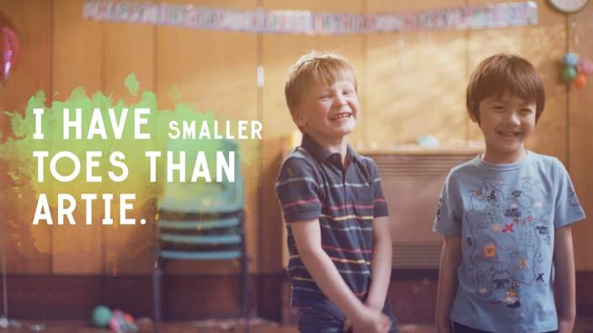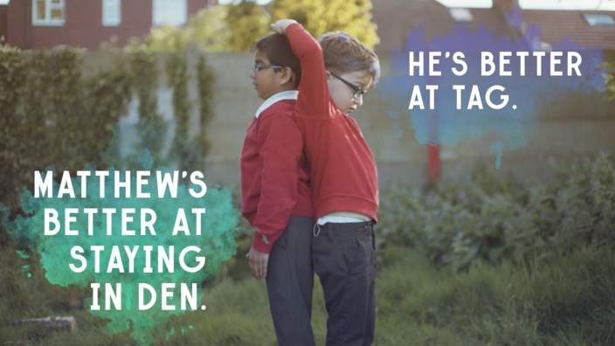
Step 7
Now show the closing caption at 01:50:
“When it comes to difference,
Children see things differently.”
Ask your students to discuss the meaning of this sentence in relation to the video.

Step 8
Hold a plenary discussion on the meaning of the sentence.
READING :
Quotations:
People may be said to resemble not the bricks of which a house is built, but the pieces of a picture puzzle, each differing in shape, but matching the rest, and thus bringing out the picture.
Felix Adler

The diversity of the family should be a cause of love and harmony, as it is in music where many different notes blend together in the making of a perfect chord.
from the Baha'i Scriptures

Diversity is not about how we differ.
Diversity is about embracing one another's uniqueness.
Ola Joseph
Peace is not unity in similarity but unity in diversity,
in the comparison and conciliation of differences.
Mikhail Gorbachev
Why not let people differ about their answers to the great mysteries
of the Universe? Let each seek one's own way to the highest, to one's
own sense of supreme loyalty in life, one's ideal of life. Let each
philosophy, each world-view bring forth its truth and beauty to a larger
perspective that people may grow in vision, stature and dedication.
Algernon Black
We all should know that diversity makes for a rich tapestry,
and we must understand that all the threads of the tapestry
are equal in value no matter what their color.
Maya Angelou

I feel my heart break to see a nation ripped apart by its own greatest strength--its diversity.
Melissa Etheridge
There never were in the world two opinions alike,
no more than two hairs or two grains; the most
universal quality is diversity.
Michel de Montaigne

We have become not a melting pot but a
beautiful mosaic. Different people, different
beliefs, different yearnings,
different hopes, different dreams.
Jimmy Carter

Cultural differences should not separate us from each other, but rather
cultural diversity brings a collective strength that can benefit all of humanity.
Robert Alan
The splendor of the rose and the whiteness of the lily do not rob
the little violet of its simple charm. If every tiny flower wanted
to be a rose, spring would lose its loveliness.
Therese of Lisieux
Diversity is the mother of balance. . . . The diversity in our lives and around
us offers us many of our best options for balancing and rebalancing. As human
beings, we push and push and push for sameness, not really seeing that this
contributes to our feelings of imbalance. We want to be around people who are
similar to us. We want our culture to cover the globe. When we travel, we want
to stay in accommodations that are "familiar" to us. We want our children to
marry someone like us. We may like the idea of diversity,
yet we want the practicality of sameness!
There are no nations! There is only humanity. And if we don't come to
understand that right soon, there will be no nations,
because there will be no humanity.
Issac Asimov
When you're finally up on the moon, looking back at the earth, all these
differences and nationalistic traits are pretty well going to blend and you're
going to get a concept that maybe this is really one world and why the
hell can't we learn to live together like decent people?
Frank Borman
Diversity is the most basic principle of creation.
No two snowflakes, blades of grass, or people are alike.
Lynn Maria Laitala
I am in harmony with God's beautiful world. A summer bouquet may include an
assortment of flowers in a rainbow of colors. The variety makes the whole bouquet
even more beautiful. I realize I am one flower in the wondrous bouquet of humanity.
Without judging or comparing myself to others, I enjoy the unique beauty in all of us.
I am a divine expression of God and so is everyone else. As I value our commonalities
and our differences, I experience harmony. I relax into knowing that I am loved and
that I have a unique contribution to make. As I learn to love myself, I am at peace--
with myself and others. Living in peace, I am in harmony with God's beautiful world.
unattributed (Daily Word)

People need to see that far from being an obstacle, the world's diversity of
languages, religions, and traditions is a great treasure, affording us precious
opportunities to recognize ourselves in others.
Youssou N'Dour

Differences are not intended to separate, to alienate. We are
different precisely in order to realize our need of one another.
Desmond Tutu
Believe
TASK
They are going to take two mins to read the quotation, then they are going to stand in two rows facing one another, read the quotation to their partner then explain it.
Partners then report to the teacher what their partners’ quotations were about and their pairs should correct them if they are mistaken.

Production:

Write a message to the world propagating diversity.

